MTConnect©

PCDMIS Adapter

User Guide

Draft

January 12, 2012

# Revision History

**Date Description Author Version**

|  |  |  |  |
| --- | --- | --- | --- |
| **Date** | **Author** | **Version** | **Description** |
| 12/2/11 | NIST | 1.0 | Initial PCDMIS release – no tolerance reporting |

# Copyright

*Software produced by the National Institute of Standards and Technology (NIST), an agency of the U.S. government and by statute is not subject to copyright in the United States. Recipients of this software assume all responsibility associated with its operation, modification, maintenance, and subsequent redistribution.*

# 

# Disclaimer

*No approval or endorsement of any commercial product by the National Institute of Standards and Technology is intended or implied. Certain commercial equipment, instruments, or materials are identified in this report in order to facilitate understanding. Such identification does not imply recommendation or endorsement by the National Institute of Standards and Technology, nor does it imply that the materials or equipment identified are necessarily the best available for the purpose.*

# Installation

Start the setup.exe program.

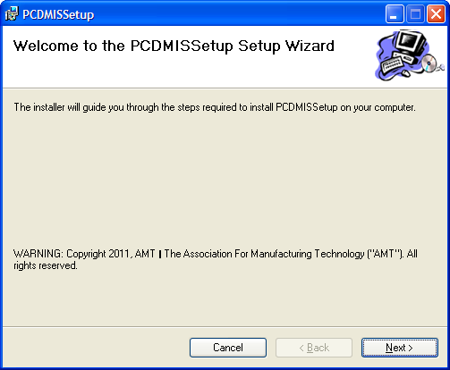

Decide if the installation directory is ok.

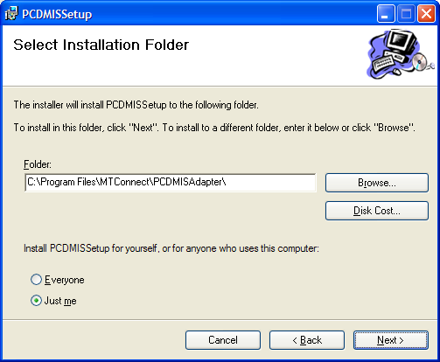

Then start the installation.

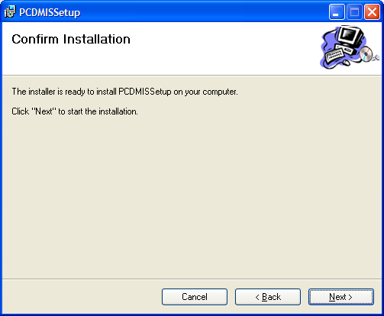

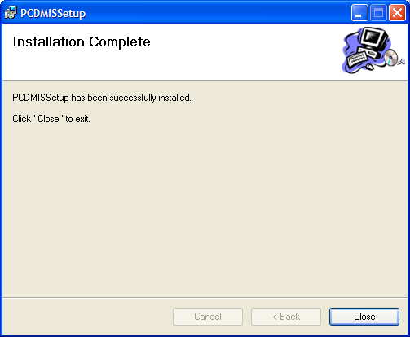

Go to the PCDMIS installation folder:

## TEST INSTALLATION:

Go the installation folder:



12/02/2011 12:39 PM 34 InstallAdapter.bat

11/01/2011 07:27 AM 59,904 PCDMIS.exe

01/13/2012 12:50 PM 109 pcdmis.ini

12/02/2011 12:39 PM 32 RunAdapter.bat

01/13/2012 12:57 PM 26 UninstallAdapter.bat

With the following functionality:

|  |  |
| --- | --- |
| Program | Description |
| InstallAdapter.bat | installs the PCDMIS adapter as a windows service. |
| PCDMIS.ini | contains configuration data. |
| PCDMIS.xml | is a sample MTConnect Agent devices file to talk to this adapter. |
| RunAdapter.bat | starts the PCDMIS adapter as a normal windows application in a console window. |
| UninstallAdapeter.bat | Uninstalls PCDMIS adapter as windows service. |

To test, run the batch file:

RunAdapter.bat

To monitor actual PCDMIS SHDR output,Start->Run->cmd then run telnet:

telnet

> open 127.0.0.1 7878

## Configuring

The pcdmis.ini file has configuration parameters:

|  |  |
| --- | --- |
| [PCDMIS] | Description |
| ProgId=PCDLRN.Application | Program id of the pcdmis COM object. |
| CycleTime=1000 | Cycle refresh time |
| ProcessId=PCDLRN.exe | Process name of PCDMIS, to |
| ServiceName=PcDmisMTConnectAdapter | Service name to install into Service Control Manager. |